Content Map & CTAs

One-Line Claim
I turn raw search data into ranking decisions that move traffic.

Content Map
Home
- Hero: one-line claim + profile photo
- Three proof cards: one screenshot per project, one sentence each
- CTA: "See the work" (scrolls to Projects)
Lead case: None (teaser page)

Projects
- Project 1 (lead): FlyRank Content Refresh scoring — warehouse queries, leakage experiment, feature frame
- Project 2: Web scraping pipeline — before/after numbers
- Project 3: Prompt engineering case study — iteration log, results
Lead case: FlyRank leads. Strongest proof, most technical depth.
CTA: "Read the case study" (links to individual project pages)

Project: FlyRank
- Problem: 78M rows of search data, no scoring system
- Process: data contract, 5 features, honest vs leaky model
- Result: accuracy numbers, what the model caught that rules missed
- Repo link + notebook screenshot
Lead case: FlyRank (full case study)
CTA: "View the notebook" (links to GitHub repo)

Project: Web Scraping
- Problem: manual data collection was slow
- Process: pipeline design, error handling
- Result: time saved, data quality improved
Lead case: Web scraping project
CTA: "See the code" (links to repo)

Project: Prompt Engineering
- Problem: inconsistent AI outputs
- Process: prompt ladder, iteration log, voice card
- Result: before/after comparison
Lead case: Prompt engineering case study
CTA: "Read the log" (links to docx)

About
- Bio: 3 sentences, what I do and what I care about
- Education + current role
- Contact: email + LinkedIn
Lead case: None
CTA: "Get in touch" (mailto link)

Still Need to Gather
- Clean screenshot of w03_data_contract.ipynb output (grain check + feature frame)
- Screenshot of leakage experiment accuracy numbers
- Repo link (already have: github.com/Abdullah-9862873/FlyRank-Internship)
- Web scraping project: before/after data quality numbers
- Prompt engineering: cleaned iteration log with final results
- Professional headshot (current one is phone-quality, needs reshoot)

Screenshots gathered:
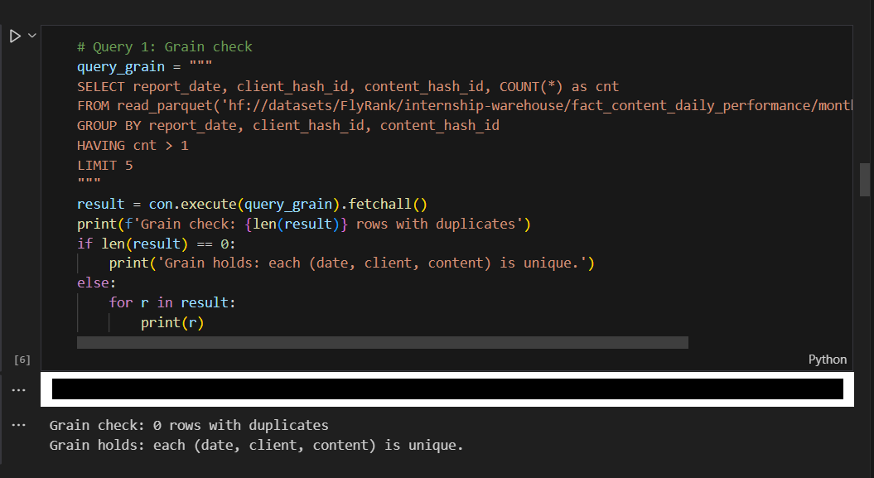
Grain check output
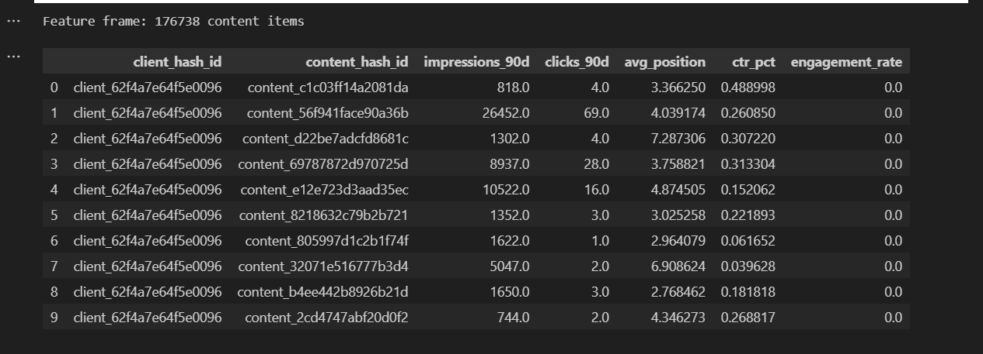
Feature frame output
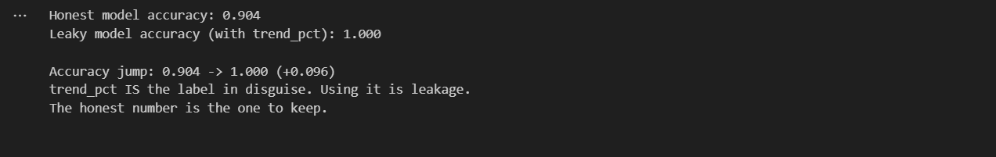
Leakage experiment accuracy
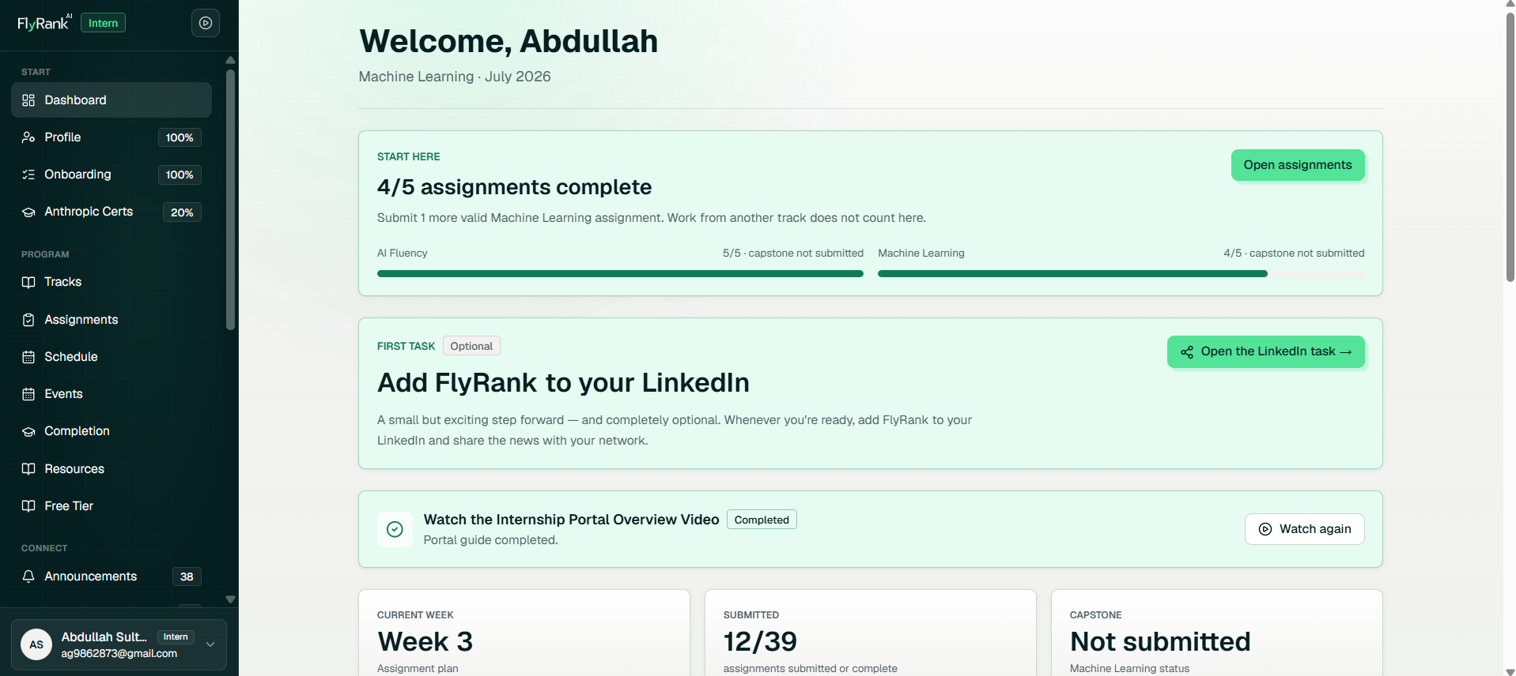
FlyRank dashboard

Profile photo
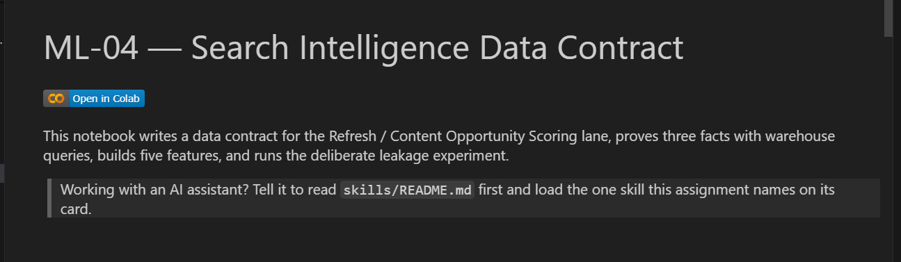
Notebook header

